ASK BILL

Question
This question was asked at a tournament this summer when an archer mentioned they were going to Creep Tune their bow and were waiting until they could get to a shop that had a bow press so they could do the necessary shortening or lengthening of the cables. I told the archer there was no need to use a bow press since their bow had the X cable system. The question at that point was about how to remove the cables and twist them without a bow press to get slack in them.

Answer
One of the real beauties of the X system is the ability to adjust draw length and timing right at the range without the use of any kind of bow press or tools to get slack in the cables. All you do is squeeze or pinch one cable to the limb about 3 inches from the axle. When you do this the other cable at that end of the bow will be slack and you can take it off the axle and twist it. After you get the slack cable off the axle, you don’t even have to keep the first cable pinched to the limb if you don’t want to. You can let go of it until you are ready to put the newly twisted cable back on the axle. See photos. The photo without my hand is what the X system looks like normally. The other photo shows me pinching one cable to the limb and the other cable is slack. The slack cable could have been removed from the axle with my other hand if it had not been taking the picture. It takes very little force or strength to do this maneuver and I bet you a donut anyone can do it. Happy Creep Tuning or draw length adjusting to all you X cable owners.
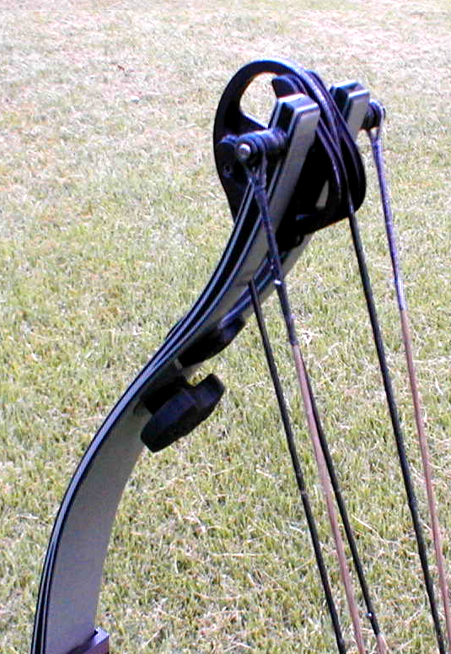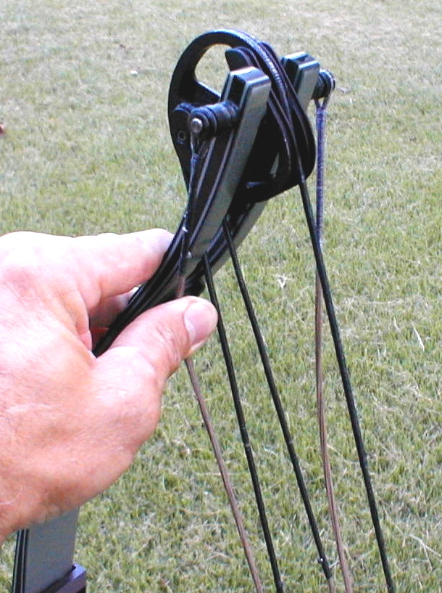

Comments
Creep tuning is something I do to my target and hunting bows whether they have the X system cabling or not; the X system just makes it easier and quicker. If you are not familiar with Creep Tuning or have questions about it please e-mail or phone me. If there is interest in it I can put something in an upcoming newsletter.

Thanks, Bill Schuh.

